【Product display and Introduction】

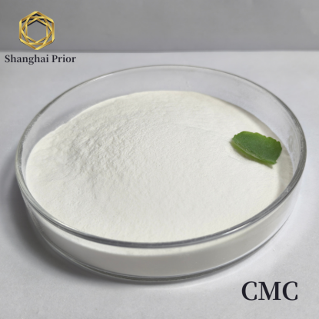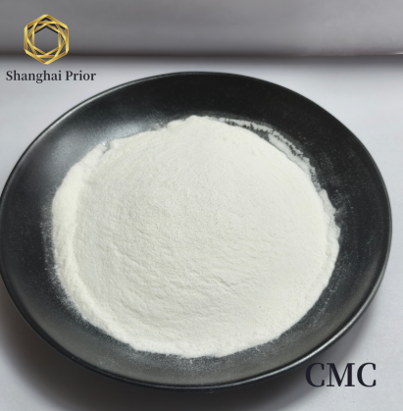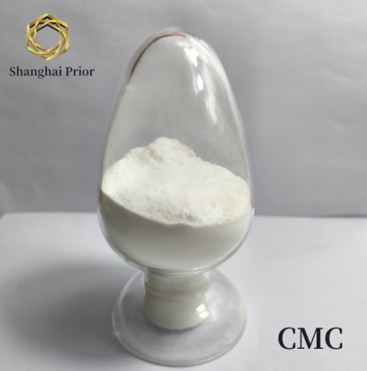

CMC is used as an additive in food, having the functions of thickening, suspension, stability, water retention, acid resistance, film formation and so on, it can replace guar gum, gelatin, AGAR, sodium alginate, pectin, xanthan gum and other functional ingredients in food production, it is widely used in modern food industry, such as acidic dairy products, beverages, ice cream, solid drinks, fruit and vegetable juice, jam, condiments, biscuits, instant noodles, baking products, meat products, etc.

【Product models and standards: 】
Specifications and models  Indicators | FH₁₀ | FFH₉ | FH₉ |  | FH_{9特高} |  | FVH9 |  | FM₉ | GFH9
2% aqueous viscosity (mpa.s) | 800-1200 | 800-1200 | 800-1200 |  | >1200 |  | >2000 |  | 600-900 | 200-500（1%）
Drying Reduction(H2O)% ≤ | 10.0
Degree of substitution(D.S) ≥ | 1.0 | 0.90
Chloride(Cl-)% ≤ | 1.2
pH | 6.0-8.5
Heavy metals(in Pb)% ≤ | 0.0015
lead（Pb）％ ≤ | 0.0005
iron(Fe)% ≤ | 0.02
arsenic(As)% ≤ | 0.0002
Specifications and models  Indicators | FL₁₀₀ | FH₆ |  | FH_{6特高} |  | FH_{6特-A} |  | FM_{9-A} |  |  | FM₆
2% aqueous viscosity (mpa.s) | 100-140 | 800-1200 |  | >1200 |  | >1200 |  | 300－800 |  |  | 300－800
Degree of substitution(D.S) ≥ | 1.00 | 0.70 |  |  |  | 0.75 |  | 0.90 |  |  | 0.70
Chloride(Cl-)% ≤ | 1.2 |  |  |  |  | 0.50 |  | 0.50 |  |  | 1.2
Drying Reduction(H2O)% ≤ | 10.0
pH | 6.0-8.5
Heavy metals(in Pb)% ≤ | 0.0015
lead（Pb）％ ≤ | 0.0005
iron(Fe)% ≤ | 0.02
arsenic(As)% ≤ | 0.0002

【Product application】
CMC is a food-grade additive, a type of anionic cellulose ether. It is a high-molecular-weight water-soluble cellulose gum derived from natural cellulose through chemical modification by grafting hydrophilic groups, resulting in an ether-structured derivative.
In food applications, CMC offers excellent rheological properties, acts as an effective protein stabilizer, serves as a low-calorie food additive, enhances texture, and extends shelf life.

【Packaging&Note】
CMC product should be packed into edible polyethylene film inner-bag enclosed by composite paper-plastic outer-bag and fiberboard drum. Net weight is 25kg per piece.
CMC product should be sealed in the condition of rain-proof，sun-resistant and hook-anti .It is should be stored in dry , moisture-proof place ,and prohibited with acidic chemicals.

